Design Document – WEBD 1000
Davi Ferreira
NSCC

Desktop Vision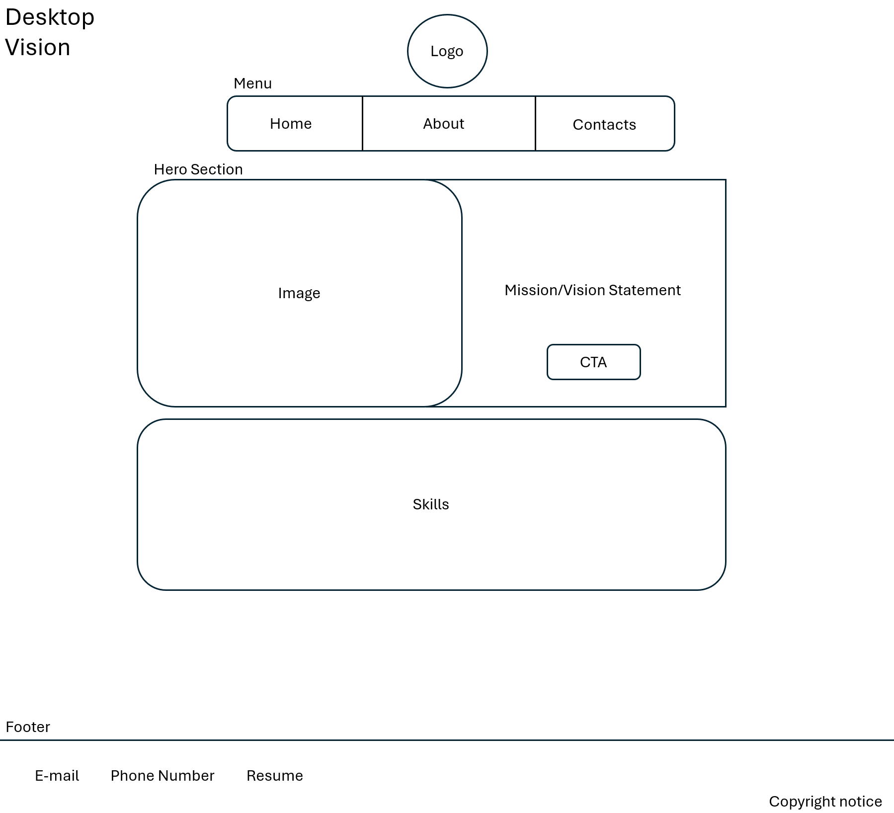

Smartphone Vision
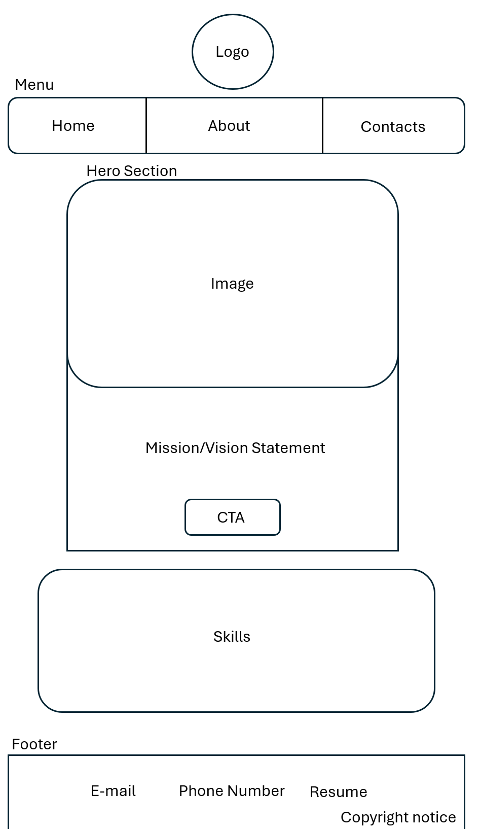

Validation Screenshot
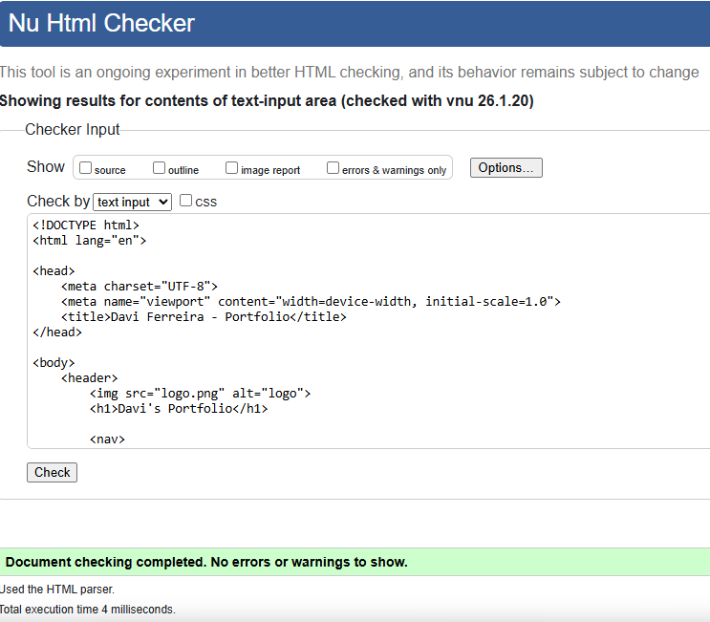

Validator HTML Pratical 8
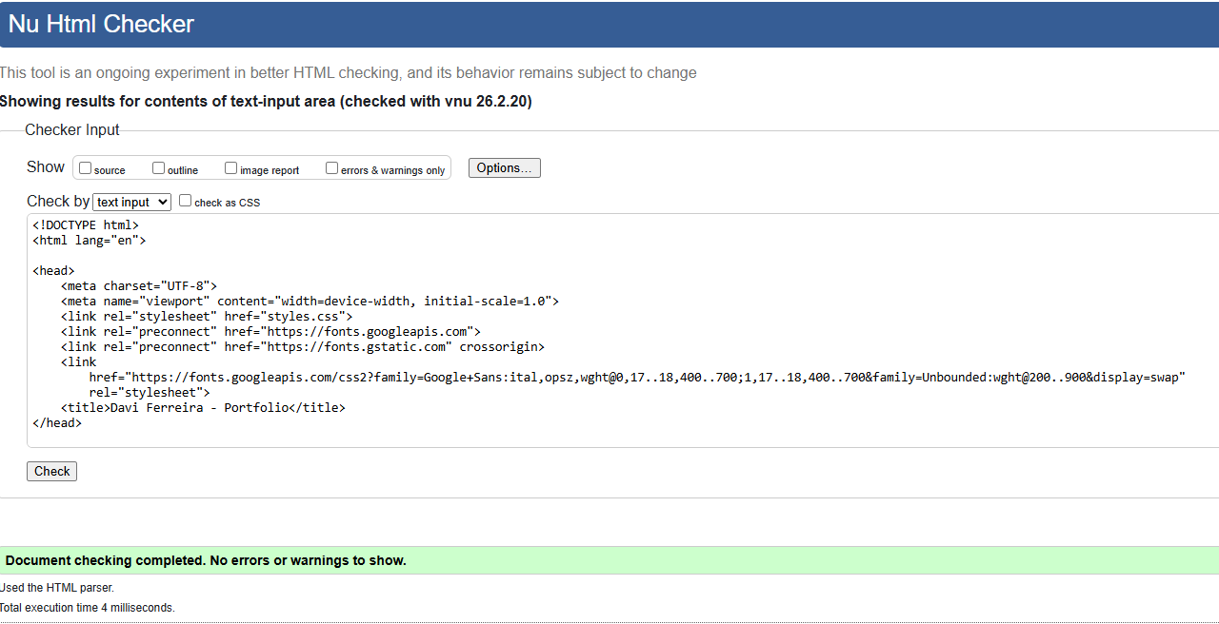

Validator CSS Pratical 8
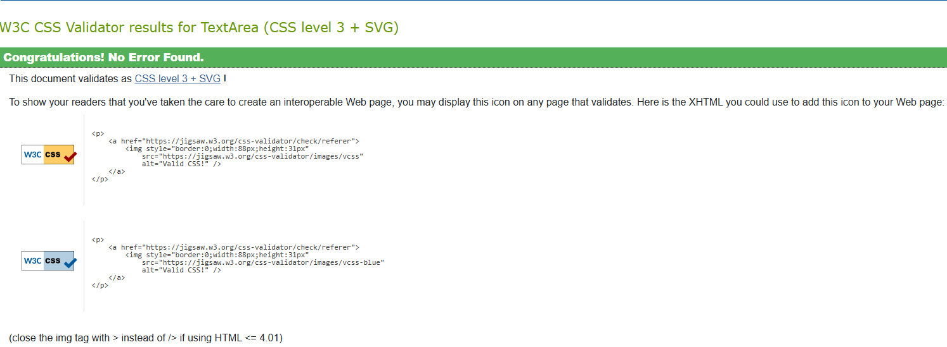

Wire Frame Reflection.
I did not change that much, the only things that are different are the sections and the nav bar, and the reason for why I did these changes was because they worked better for each media, while in the smartphone it is better to have a hamburger menu, because it is easier to tap on the option, since the option is larger, having them in row and separate in the desktop makes it easier to click the option without clicking the wrong. Also, the reason why I changed the sections on the desktop was to have a better readability, however, I still want to make them in different pages on the web browser. Furthermore, I learnt that obviously the first vision is not the right one, it is just a direction of what you might want for the future, but, even now, I don’t think the website will stay this way, it may have more changes for it in the future.

